What are the main principles of OOP?
Answer:
- Encapsulation: The binding (or wrapping) of data and methods that operate on the data into a single unit called a ‘class’. It also means hiding data (i.e., private variables) from direct access.
- Abstraction: Hiding the complex implementation details of an operation while exposing a simple interface.
- Inheritance: Allows a new class to inherit properties and methods of an existing class.
- Polymorphism: The ability of different classes to provide a unique interface by exposing a method that can behave differently.

Explain the difference between abstract classes and interfaces.
Answer:
- Abstract Class: Can have both abstract and non-abstract methods. Abstract classes are used to provide a base for subclasses to extend and implement the abstract methods.
- Interface: Typically contains abstract methods only. Starting from Java 8, it can also contain default and static methods. Interfaces are used to implement abstraction.

Java final, finally and finalize
- final: The “final” is the keyword that can be used for immutability and restrictions in variables, methods, and classes.
- finally: The “finally block” is used in exception handling to ensure that a certain piece of code is always executed whether an exception occurs or not.
- finalize: finalize is a method of the object class, used for cleanup before garbage collection.

Java Exception Hierarchy
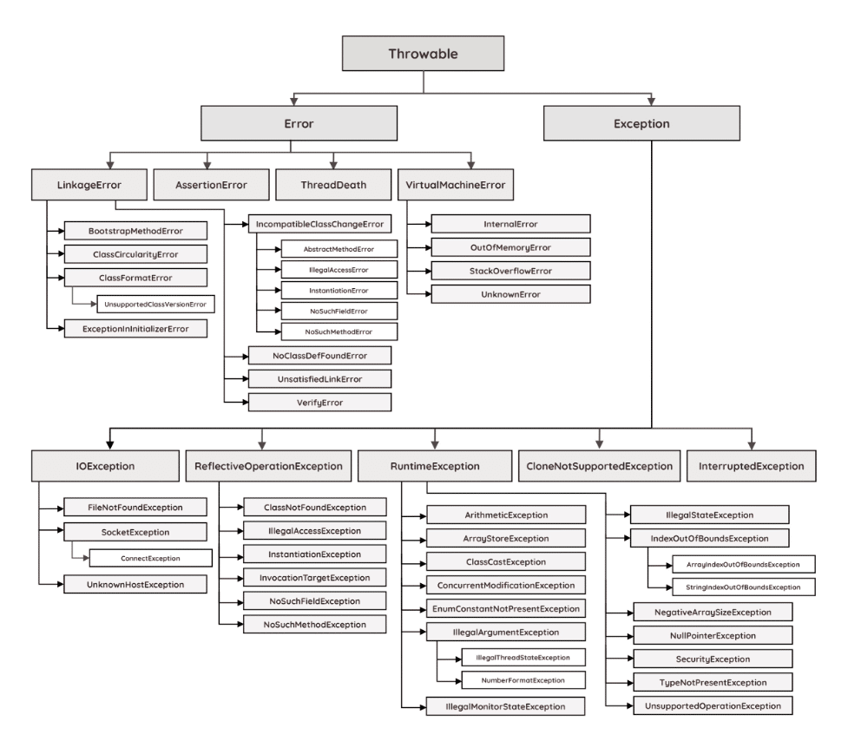

Explain "String", "StringBuilder", and "StringBuffer".
Answer:
- String: Immutable sequence of characters.
- StringBuilder: Mutable sequence of characters. Not thread-safe.
- StringBuffer: Mutable sequence of characters. Thread-safe.

What is the difference between "ArrayList" and "LinkedList"?
Answer:
ArrayList: Resizable-array implementation of the List interface. Best for storing and accessing data.
LinkedList: Doubly-linked list implementation of the List interface. Better for operations that require frequent addition and removal of elements from any part of the list.
Lifecycle of Threads
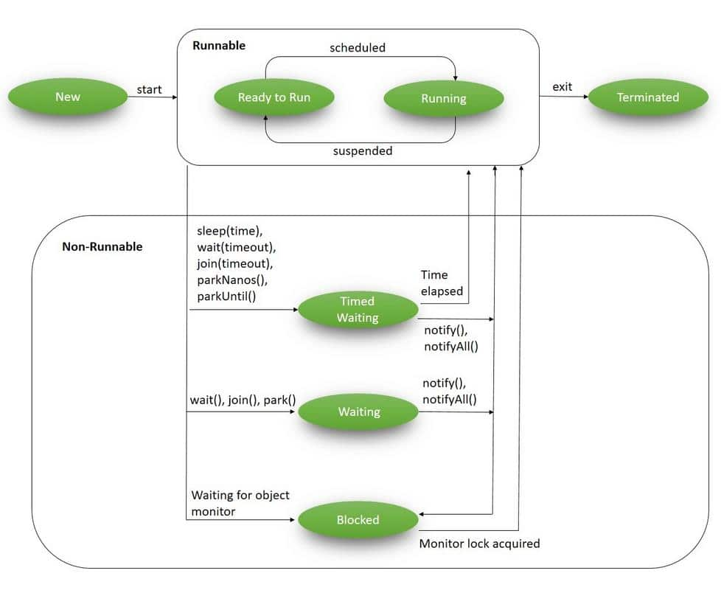

What is the difference between 'map' and 'flatMap' in Streams?
Answer:
- map: It transforms each element in the stream using the given function. It is a one-to-one mapping.
- flatMap: It helps in converting one type of stream element into another type and flattens the Stream of Streams into a Stream.

What are terminal operations on "Streams"?
Answer: Terminal operations produce a result from a stream pipeline. Terminal operations include operations like forEach, reduce, collect, and sum.
Describe and compare fail-fast and fail-safe iterators
- Fail-fast iterators operate directly on the collection itself. During iteration, fail-fast iterators fail as soon as they realize that the collection has been modified (i.e., upon realizing that a member has been added, modified, or removed) and will throw a ConcurrentModificationException. Some examples include ArrayList, HashSet, and HashMap (most JDK1.4 collections are implemented to be fail-fast).
- Fail-safe iterates operate on a cloned copy of the collection and therefore do not throw an exception if the collection is modified during iteration. Examples would include iterators returned by ConcurrentHashMap or CopyOnWriteArrayList.

What is TheadLocal ?
The TheadLocal construct allows us to store data that will be accessible only by a specific thread. It’s a reasonable way of achieving thread safety.
ThreadLocal<String> str = new ThreadLocal<String>();

Sleep vs Wait
sleep() is a blocking operation that keeps a hold on the monitor / lock of the shared object for the specified number of milliseconds.
wait(), on the other hand, simply pauses the thread until either (a) the specified number of milliseconds have elapsed or (b) it receives a desired notification from another thread (whichever is first), without keeping a hold on the monitor/lock of the shared object.
sleep() is most commonly used for polling, or to check for certain results, at a regular interval. wait() is generally used in multithreaded applications, in conjunction with notify() / notifyAll(), to achieve synchronization and avoid race conditions.

What is the Java Classloader? List and explain the purpose of the three types of class loaders.
Hide answer
The Java Classloader is the part of the Java runtime environment that loads classes on demand (lazy loading) into the JVM (Java Virtual Machine). Classes may be loaded from the local file system, a remote file system, or even the web.
When the JVM is started, three class loaders are used:
1. Bootstrap Classloader: Loads core java API file rt.jar from folder.
2. Extension Classloader: Loads jar files from folder.
3. System/Application Classloader: Loads jar files from path specified in the CLASSPATH environment variable.

Java Memory Management

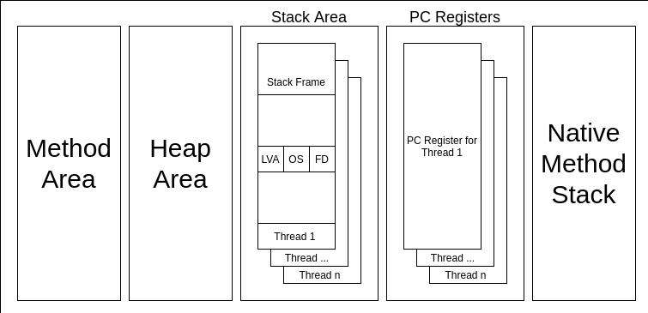
- Method area, part of the heap in the HotSpot JVM implementation, stores class-level data such as static variables, bytecode, and runtime constant pool information. It is shared among all threads and is crucial for class loading and linking.
- Stack stores local variables and method call information. Each thread has its own stack, which helps maintain thread safety.
- PC register, which keeps track of the current instruction being executed
- Native stack is used by Java Native Interface (JNI)
- Heap
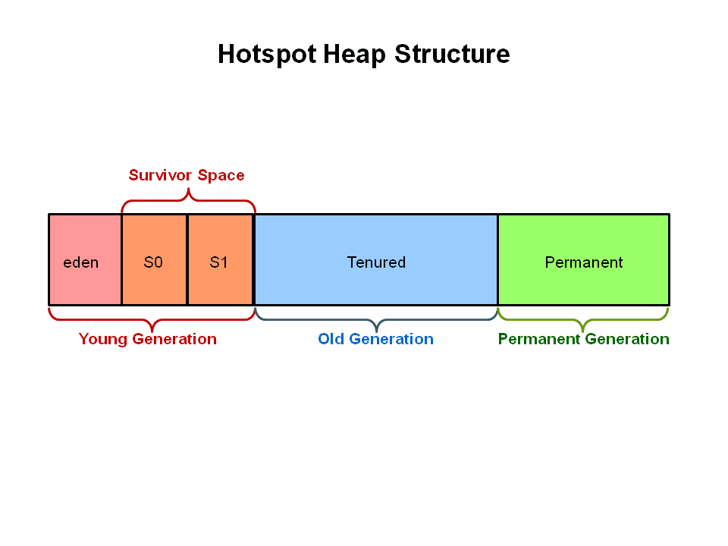

is-a vs has-a relationship
- "is-a" relationships are implemented through inheritance, where a class inherits properties and methods from a parent class. Example: A Dog is an Animal.
- "has-a" relationships are implemented through composition, where one class contains an instance of another class. Example: Car has an engine

Composition vs Aggregation
- Composition:
  - Stronger Relationship: One class (the "whole") owns another class (the "part"), and the "part" cannot exist without the "whole".
  - Example: A car "has" an engine (the engine cannot exist without the car).
  - Lifecycle: The "part" object's lifecycle is tied to the "whole" object's lifecycle.
  - Implementation: You create and manage the "part" object within the "whole" object.
- Aggregation:
  - Weaker Relationship: One class (the "whole") has a reference to another class (the "part"), but the "part" can exist independently.
  - Example: A university "has" departments (departments can exist independently of the university).
  - Lifecycle: The "part" object's lifecycle is not tied to the "whole" object's lifecycle.
  - Implementation: You typically use a reference to the "part" object, not creating it within the "whole" object.

Volatile vs transient
- volatile keyword is a non-access modifier that ensures a variable's value is always read from and written to main memory, bypassing thread-specific caches, guaranteeing visibility of changes across threads
- transient keyword is a modifier used to prevent a specific field from being serialized, meaning its value won't be saved or transmitted during object serialization.

What is runtime polymorphism or dynamic method dispatch?
Dynamic method dispatch is a resolving mechanism for method overriding during the run time. Method overriding is the one where the method in a subclass has the same name, parameters, and return type as a method in the superclass. When the over-ridden method is called through a superclass reference, java determines which version (superclass or subclass) of that method is to be executed based upon the type of an object being referred to at the time the call occurs. Thus the decision is made at run time. This is referred to as dynamic method dispatch.

BlockingQueue
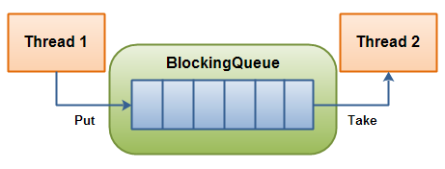
The producing thread will keep producing new objects and insert them into the BlockingQueue, until the queue reaches some upper bound on what it can contain. It's limit, in other words. If the blocking queue reaches its upper limit, the producing thread is blocked while trying to insert the new object. It remains blocked until a consuming thread takes an object out of the queue.
The consuming thread keeps taking objects out of the BlockingQueue to processes them. If the consuming thread tries to take an object out of an empty queue, the consuming thread is blocked until a producing thread puts an object into the queue.

Design Patterns

Spring Boot

What Is Inversion of Control?
Inversion of Control is a principle in software engineering which transfers the control of objects or portions of a program to a container or framework. We most often use it in the context of object-oriented programming.
What Is Dependency Injection?
Dependency injection is a pattern we can use to implement IoC, where the control being inverted is setting an object’s dependencies.
Connecting objects with other objects, or “injecting” objects into other objects, is done by an assembler rather than by the objects themselves.

What Are the Benefits of Using Spring?

- Lightweight – There is a slight overhead of using the framework in development.
- Inversion of Control (IoC) – Spring container takes care of wiring dependencies of various objects instead of creating or looking for dependent objects.
- Aspect-Oriented Programming (AOP) – Spring supports AOP to separate business logic from system services.
- IoC container – manages Spring Bean life cycle and project-specific configurations
- MVC framework – used to create web applications or RESTful web services, capable of returning XML/JSON responses
- Transaction management – reduces the amount of boilerplate code in JDBC operations, file uploading, etc., either by using Java annotations or by Spring Bean XML configuration file
- Exception Handling – Spring provides a convenient API for translating technology-specific exceptions into unchecked exceptions.

What are the bean scopes available in Spring?
The Spring Framework has five scope supports. They are:
- Singleton: The scope of bean definition while using this would be a single instance per IoC container.
- Prototype: Here, the scope for a single bean definition can be any number of object instances.
- Request: The scope of the bean definition is an HTTP request.
- Session: Here, the scope of the bean definition is HTTP-session.
- Global-session: The scope of the bean definition here is a Global HTTP session.

Are Singleton Beans Thread-Safe?
Yes, singleton beans in Spring are thread-safe by default. singleton beans in Spring are thread-safe as long as they are stateless or properly synchronized when dealing with mutable state.
What is auto wiring and name the different modes of it?

- no: This means no autowiring and is the default setting. An explicit bean reference should be used for wiring.
- byName: The bean dependency is injected according to the name of the bean. This matches and wires its properties with the beans defined by the same names as per the configuration.
- byType: This injects the bean dependency based on type.
- constructor: Here, it injects the bean dependency by calling the constructor of the class. It has a large number of parameters.
- autodetect: First the container tries to wire using autowire by the constructor, if it isn't possible then it tries to autowire by byType.

How Can We Inject Beans in Spring?
A few different options exist in order to inject Spring beans: https://www.geeksforgeeks.org/spring-setter-injection-vs-constructor-injection/
- Constructor injection (best for mandatory dependencies)
- Setter injection (best for optional dependencies)
- Field injection

What Are Aspect, Advice, Pointcut and JoinPoint in AOP?
- Aspect – a class that implements cross-cutting concerns, such as transaction management
- Advice – the methods that get executed when a specific JoinPoint with matching Pointcut is reached in the application
- Pointcut – a set of regular expressions that are matched with JoinPoint to determine whether Advice needs to be executed or not
- JoinPoint – a point during the execution of a program, such as the execution of a method or the handling of an exception

What Are the Mono and Flux Types?
The WebFlux framework in Spring Framework 5 uses Reactor as its async foundation.
This project provides two core types: Mono to represent a single async value and Flux to represent a stream of async values. They both also implement the Publisher interface defined in the Reactive Streams specification.
What Is the Use of WebClient and WebTestClient?
WebClient is a component in the new Web Reactive framework that can act as a reactive client for performing non-blocking HTTP requests. Since it’s reactive client, it can handle reactive streams with back pressure, and it can take full advantage of Java 8 lambdas. It can also handle both sync and async scenarios.
On the other hand, the WebTestClient is a similar class that we can use in tests. Basically, it’s a thin shell around the WebClient. It can connect to any server over an HTTP connection. It can also bind directly to WebFlux applications using mock request and response objects, without the need for an HTTP server.

The @SpringBootApplication annotation is a convenience annotation provided by Spring Boot. It serves as the entry point for the Spring Boot application. It combines three commonly used annotations: @Configuration, @EnableAutoConfiguration, and @ComponentScan

@Configuration vs @Component
@Configuration Indicates that a class declares one or more @Bean methods and may be processed by the Spring container to generate bean definitions and service requests for those beans at runtime
@Component Indicates that an annotated class is a "component". Such classes are considered as candidates for auto-detection when using annotation-based configuration and classpath scanning.
@Configuration is meta-annotated with @Component, therefore @Configuration classes are candidates for component scanning

Explain the difference between @Component, @Repository, @Service, and @Controller annotations in Spring Boot.

Transaction Propagation:
- REQUIRED (Default): Joins an existing transaction if one exists; otherwise, creates a new one.
- REQUIRES_NEW: Always creates a new transaction, suspending any existing one.
- NESTED: Creates a nested transaction within an existing one, allowing rollback of the nested transaction without affecting the outer one.
- SUPPORTS: Supports an existing transaction; if none exists, executes without a transaction.
- NOT_SUPPORTED: Executes non-transactionally, suspending any existing transaction.
- MANDATORY: Requires an existing transaction; throws an exception if none exists.
- NEVER: Throws an exception if a transaction exists, otherwise executes non-transactionally.
Transaction Isolation:
- DEFAULT: Uses the default isolation level of the underlying database.
- READ_UNCOMMITTED: Allows reading uncommitted data, potentially leading to dirty reads.
- READ_COMMITTED: Prevents dirty reads but not non-repeatable or phantom reads.
- REPEATABLE_READ: Prevents dirty, non-repeatable, but phantom reads can happen
- SERIALIZABLE: The highest isolation level, preventing all read anomalies.

